SPEECH TECHNOLOGIES AND BIG DATA
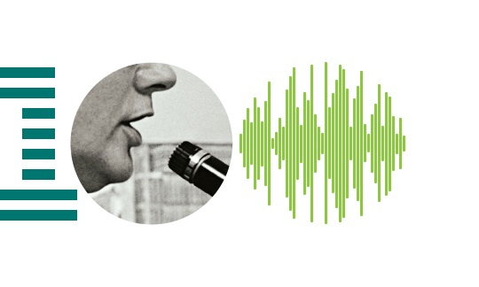
Speech Recognition Using Language And Acoustic Model Modifications

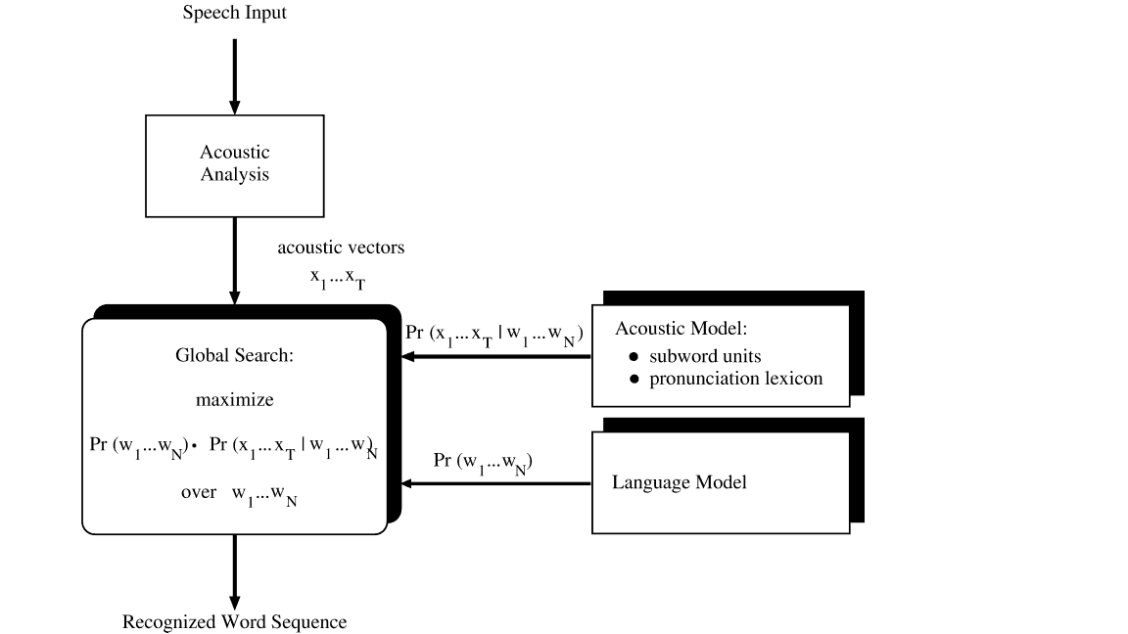
This project aims at improving accuracy of continuous speech recognition in English and other languages. The techniques used are the retrospective recognition. Here the first few words of a speech which may be feeble are recognized using the later part or the context of the speech and modifying the language mode. Databases of phrases are checked and according to the context match is made and it is returned hence improving the accuracy speech recognition. We use the CMU Sphinx toolkit for the training and recognition. CMU Sphinx is a group of speech recognition tools developed by Carnegie Mellon University which includes a series of speech recognizers and an acoustic and language model trainers (SphinxTrain)

Team
Prateek C. and R. Shwetha
6th Semester CSE

Mentor
Prof. Haripriya S.

